Moral Uncertainty

Nash voting:

Nash voting has Nash equilibria as its solution concept. At each time step, each theory provides a continuous-valued vote for or against each of the available actions. The action with the largest credence-weighted vote at each time step is executed.

Variance Voting:

The preferences of theories should be variance-normalized across decision options, giving rise to variance voting. The Qi function should be normalized by the expected value of its variance across timesteps.



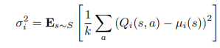



**Difference** : The main difference between nash voting and variance voting is that in nash voting a budget is allocated to each theory and the action with the largest credence-weighted vote at each time step is executed. Where as in variance voting preference of the theory is calculated as a q function and by performing the variance normalization the policy is predicted.

For nash voting PPO rl agent is used. For Variance voting Sarsa Rl agent is used.

The simulations are carried out for 100000 episodes once with Dempster credence and once without Dempster credence. The comparative analysis provides the proof that the agent was able to perform better or similar to the random credence with the Dempster credence when everything else remained same. From the plots we can see inclusion of the Dempster credence only improved the performance but not effected it negatively.

Plots

Classic Environment

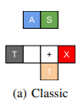

Nothing: Will let the trolley hit the X no of people on track

Switch: will change the direction of the trolley towards the 1 person on side track

**Nash Voting**

Dempster Credence Random Credence 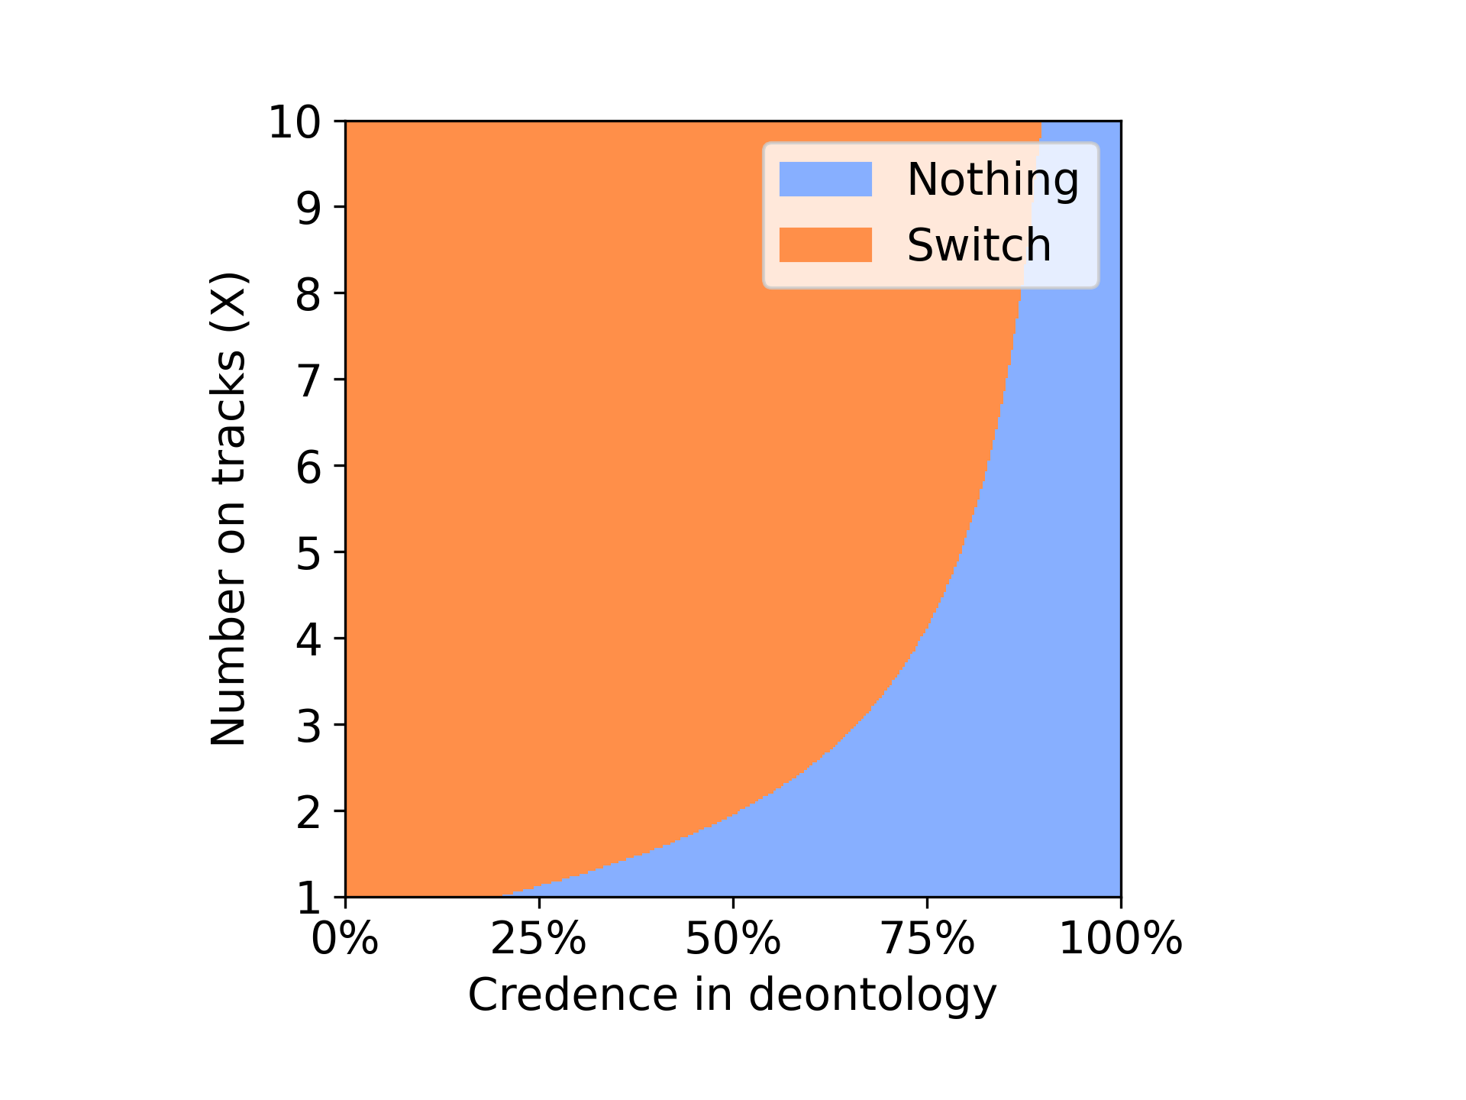 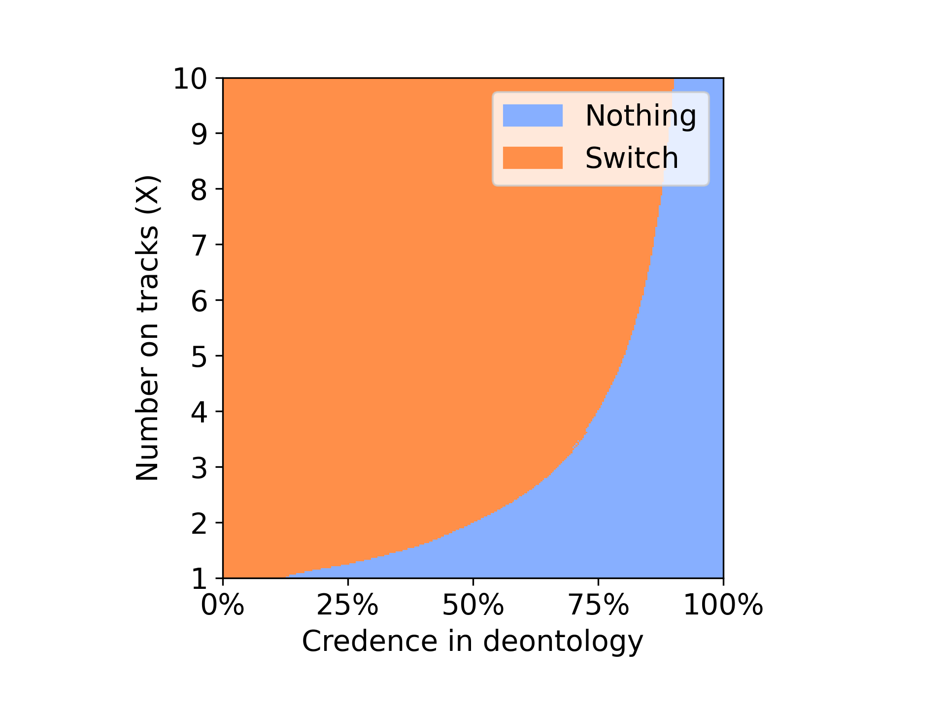

From the above plots we can observe that with the Dempster credence the agent was able to select switch option for initial 25% of the time saving the X no of people on the track where as when random credence is used after approx 10% of the time the agent started choosing the option of choosing to do nothing leaving the X no of people to die on track favouring the deontologist. Switch option resembles utilitarian we can say that using Dempster credence in nash voting favours utilitarian in classic environment.

Classic Environment 10000 iterations.

**Nash Voting**

Dempster Credence Random Credence

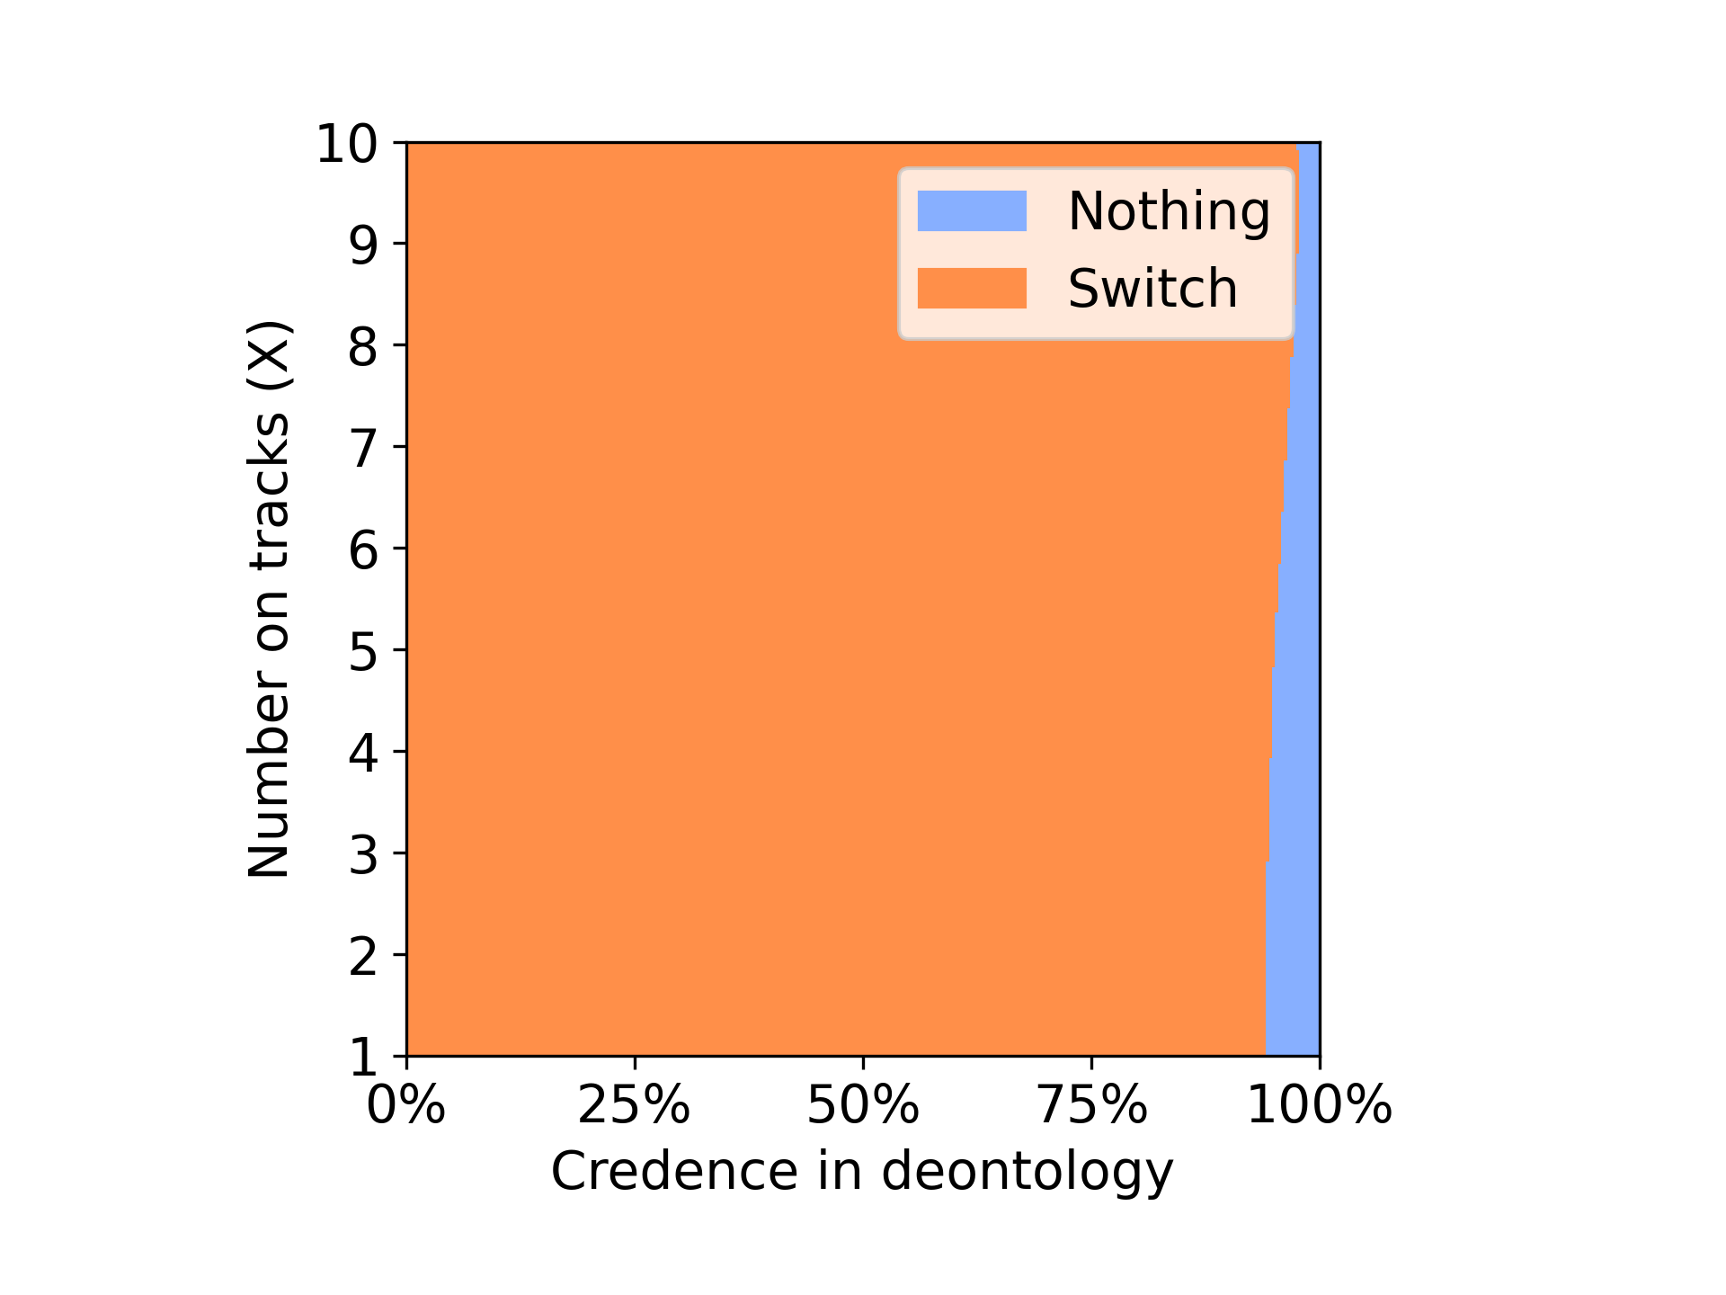 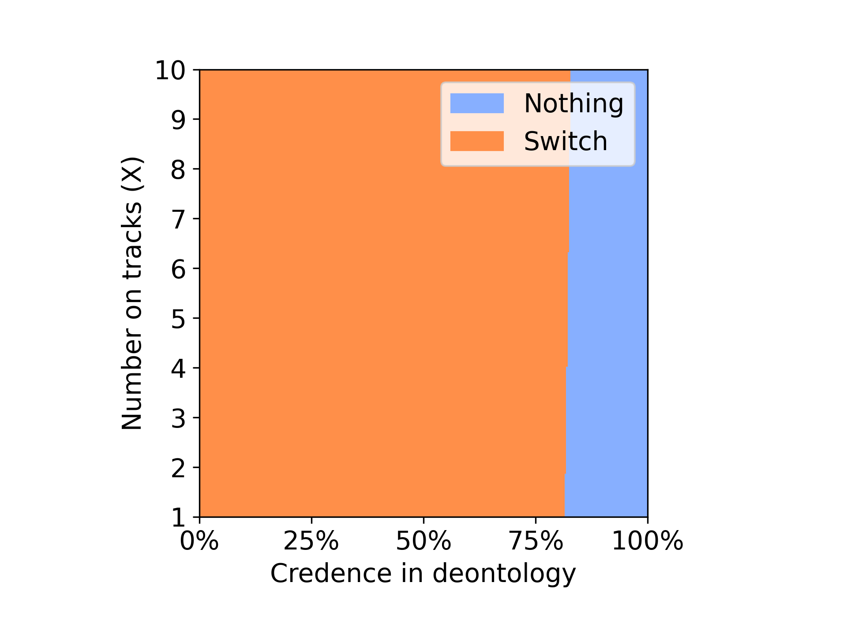

Variance voting

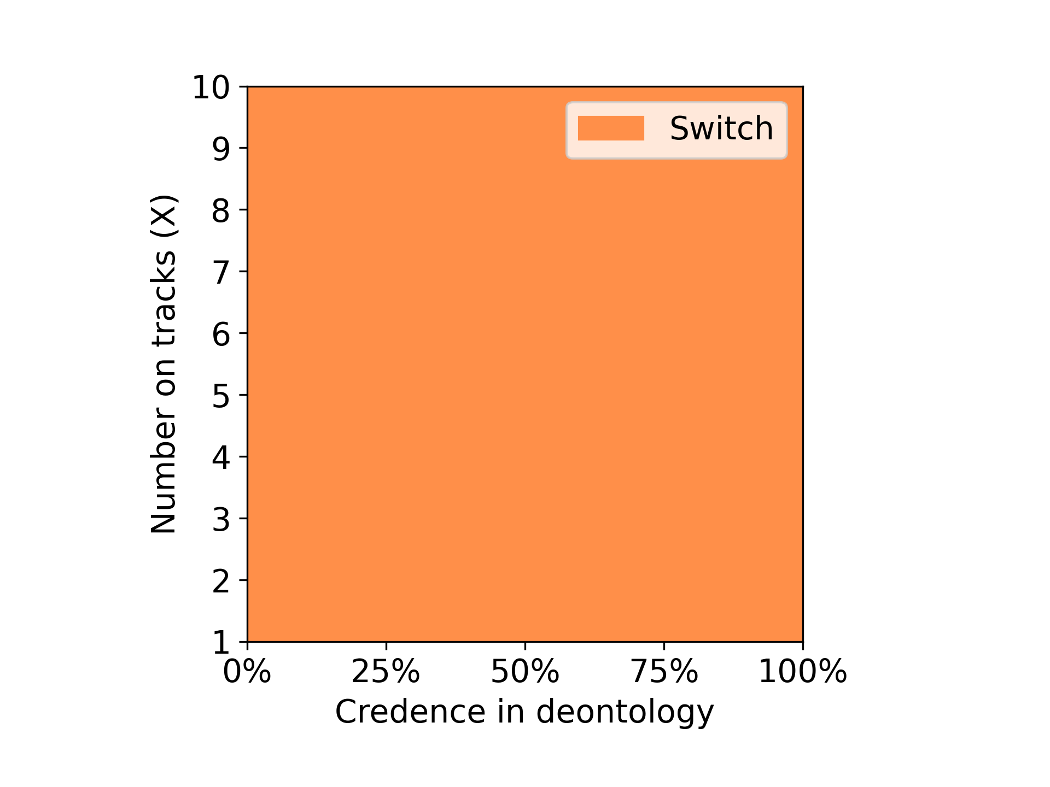 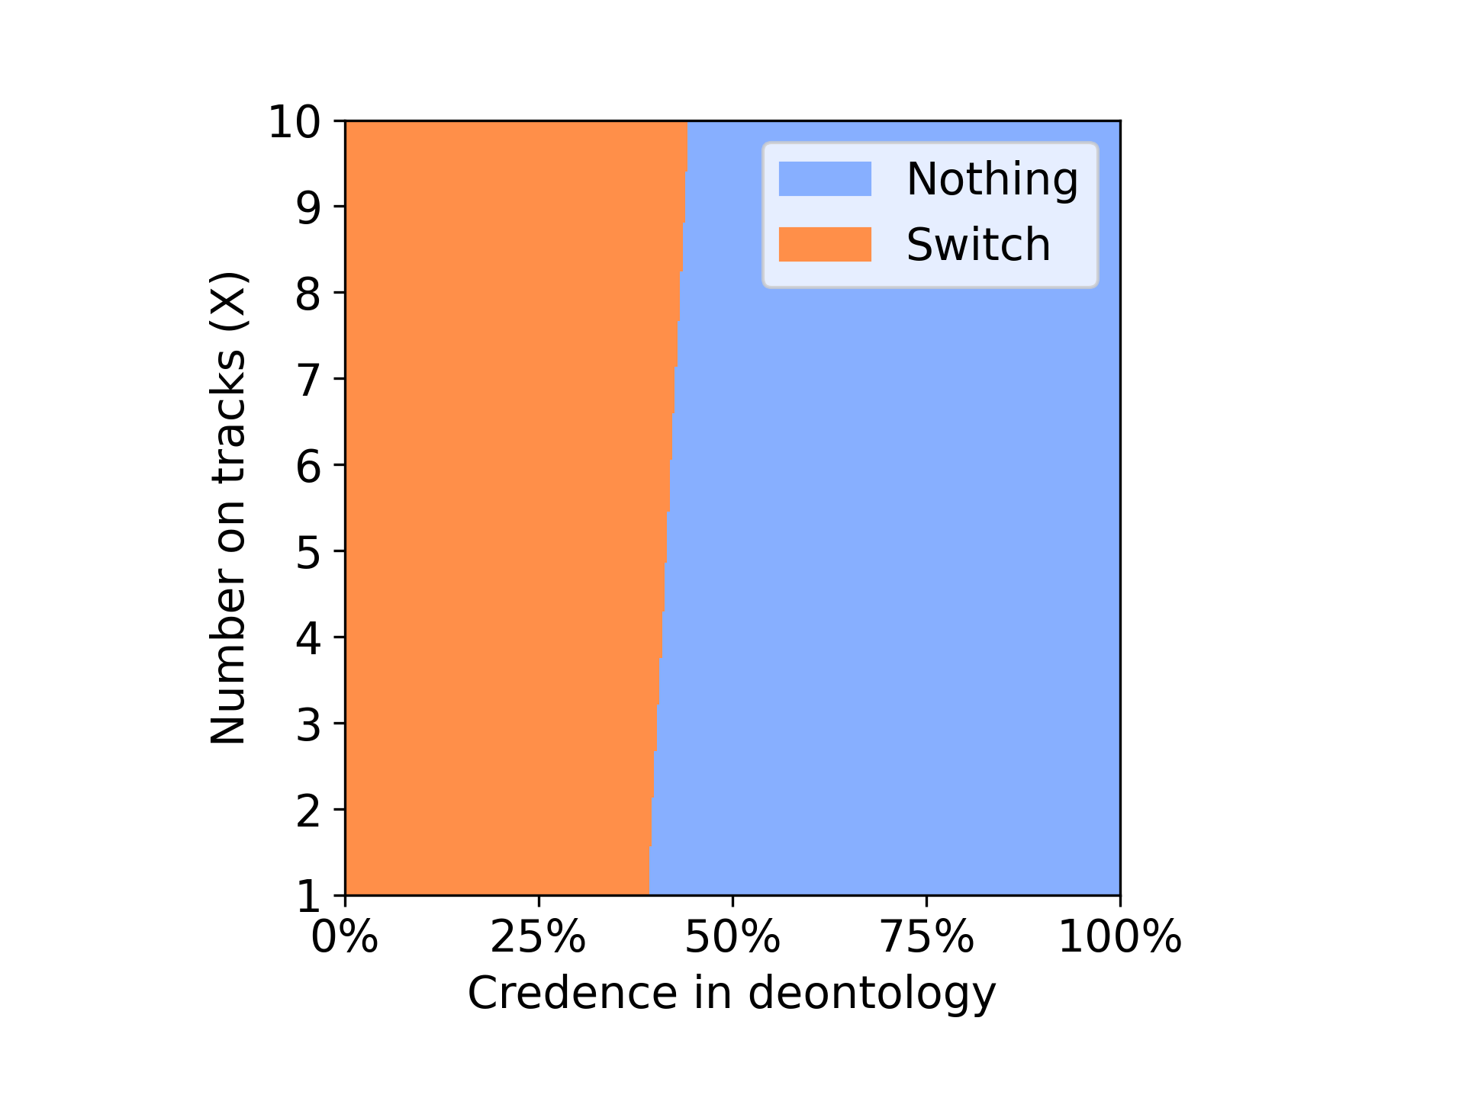

Classic Environment

Nothing: Will let the trolley hit the X no of people on track

Switch: will change the direction of the trolley towards the 1 person on side track



**Variance Voting**

Dempster Credence Random Credence

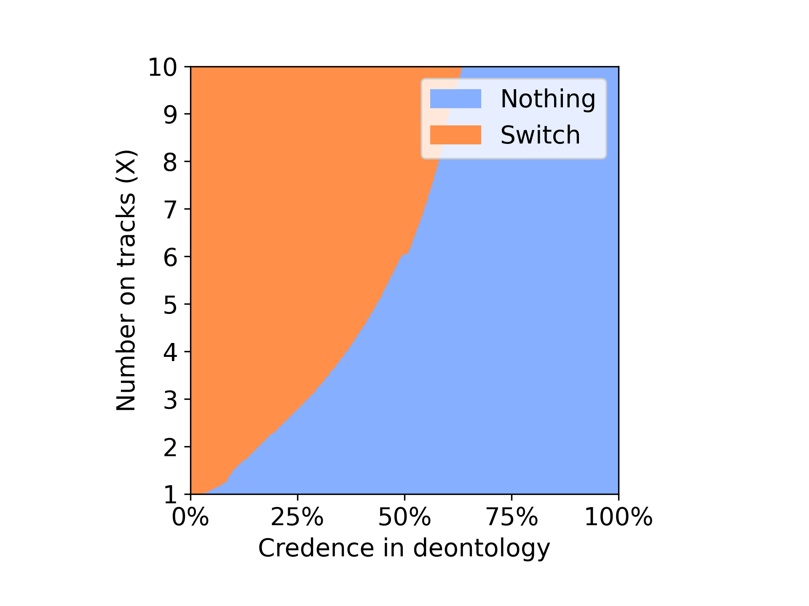 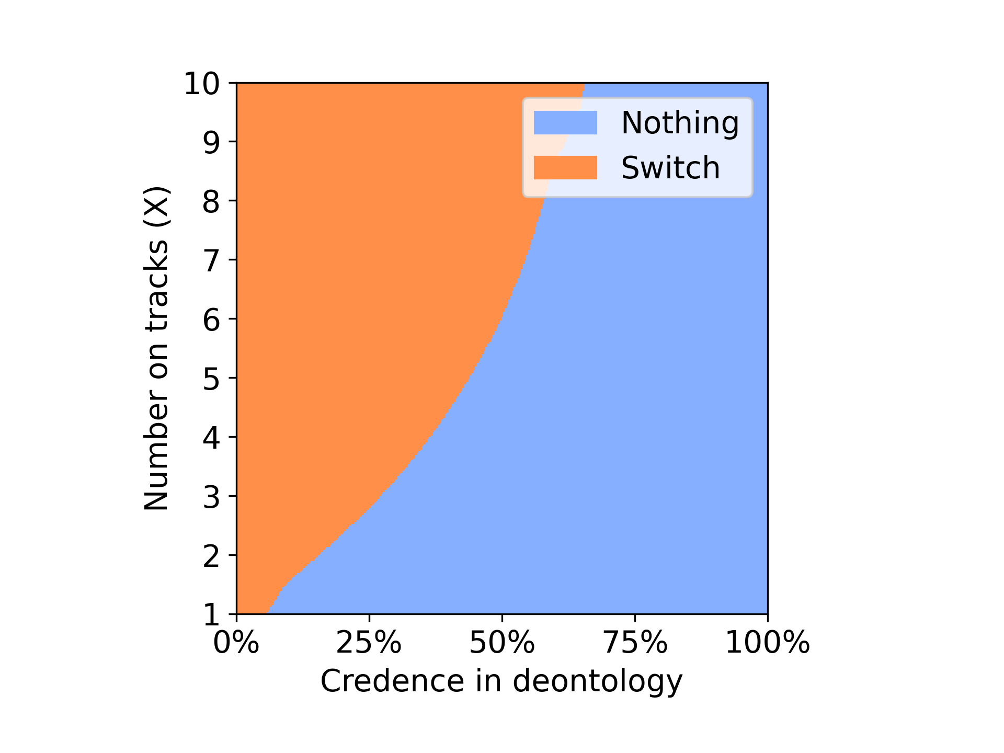

The above plots describe the performance of agent with variance voting method using Dempster credence and random credence. Here both the agents perform mostly similar with small variations from which we can infer that having the Dempster credence will not effect the existing performance of the model.

DOUBLE

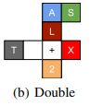

Nothing: Will let the trolley hit the X no of people on track

Switch: will change the direction of the trolley towards the 2 person on side track

Push: Will push the heavy person on the track to stop the trolley

**Nash Voting**

Dempster Credence Random Credence

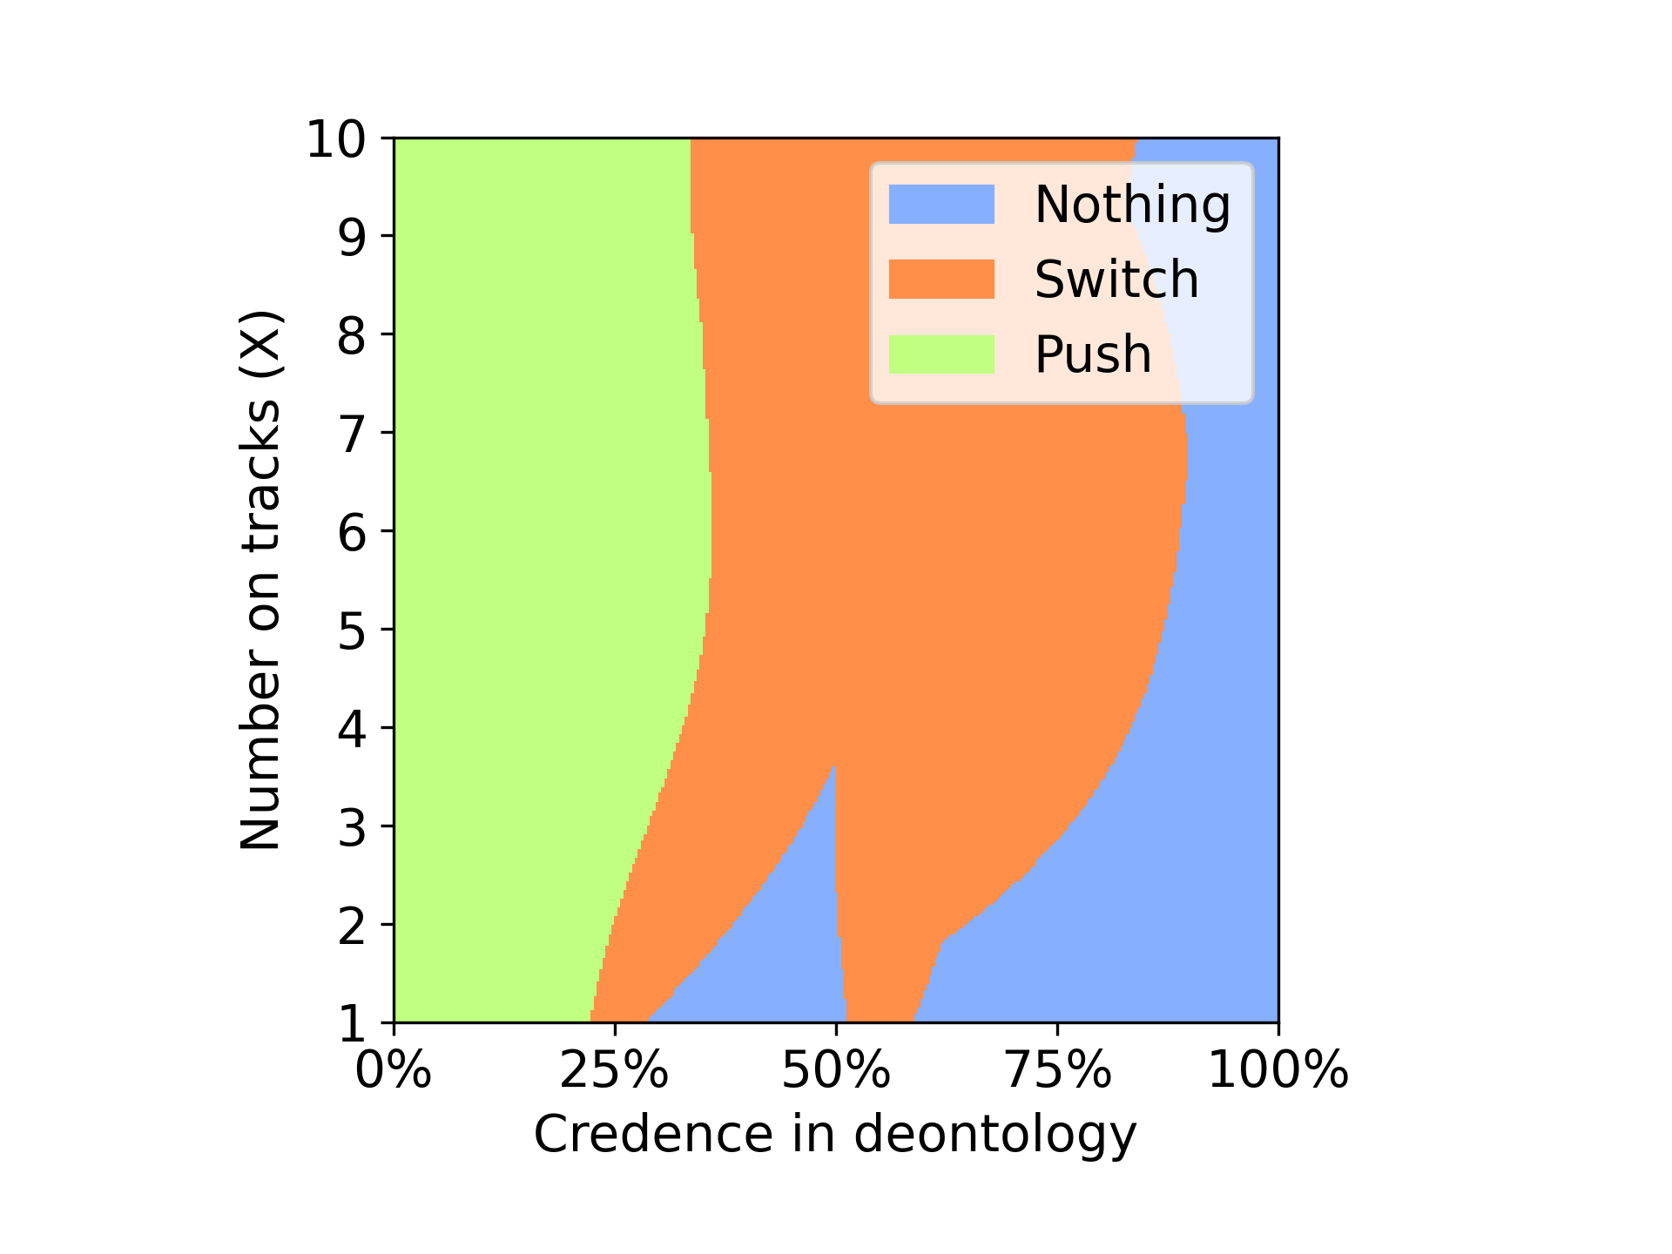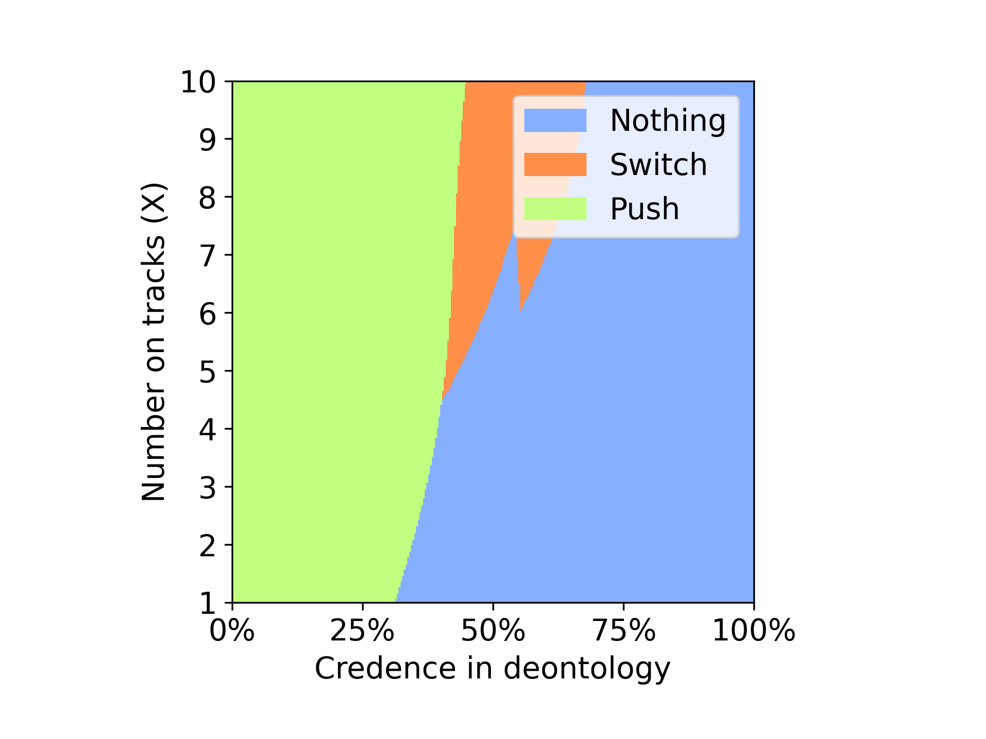

Above plots are representing the behavior of the agent using Nash voting in a double environment with Dempster credence and random credence. It is clear from the plot that the agent with Dempster credence is saving the more no of people for most of the time unlike the agent with random credence where after the 50% of time agent choose to do nothing where X no of people are left to die.

We can see that in nash voting with Dempster credence as seen in classic environment the agent is preferring the utilitarian instead of deontologist like in the case where agent uses random credence.

DOUBLE



Nothing: Will let the trolley hit the X no of people on track

Switch: will change the direction of the trolley towards the 2 person on side track

Push: Will push the heavy person on the track to stop the trolley

**Variance Voting**

Dempster Credence Random Credence

The above plots represent the behavior of agent in variance voting model with Dempster credence and random credence. From the plots we can see that the agent in the Dempster credence was able to choose between push for about 10% of the time later its choice changed to switch for major portion of the first 78% of the time. The agent with random credence was seen to be chosen switch from the starting of the simulation. We can only see that after 75% the agent with random credence choose to do nothing representing the preference for deontologist.

Here we can see that agent with Dempster credence was saving more no of people. We can see that Dempster credence in this case is favoring the utilitarian unlike the random credence.

Guard

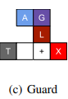

Nothing: Will let the trolley hit the X no of people on track

Push: Will push the heavy person on the track to stop the trolley by lie

Lie only: Will lie to the guard but not push the person

**Nash Voting**

Dempster Credence Random Credence

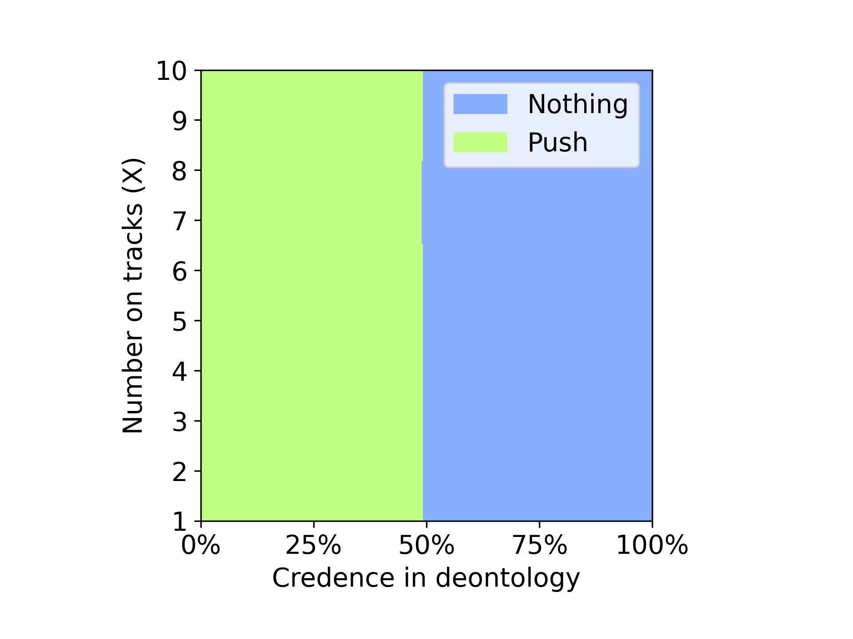 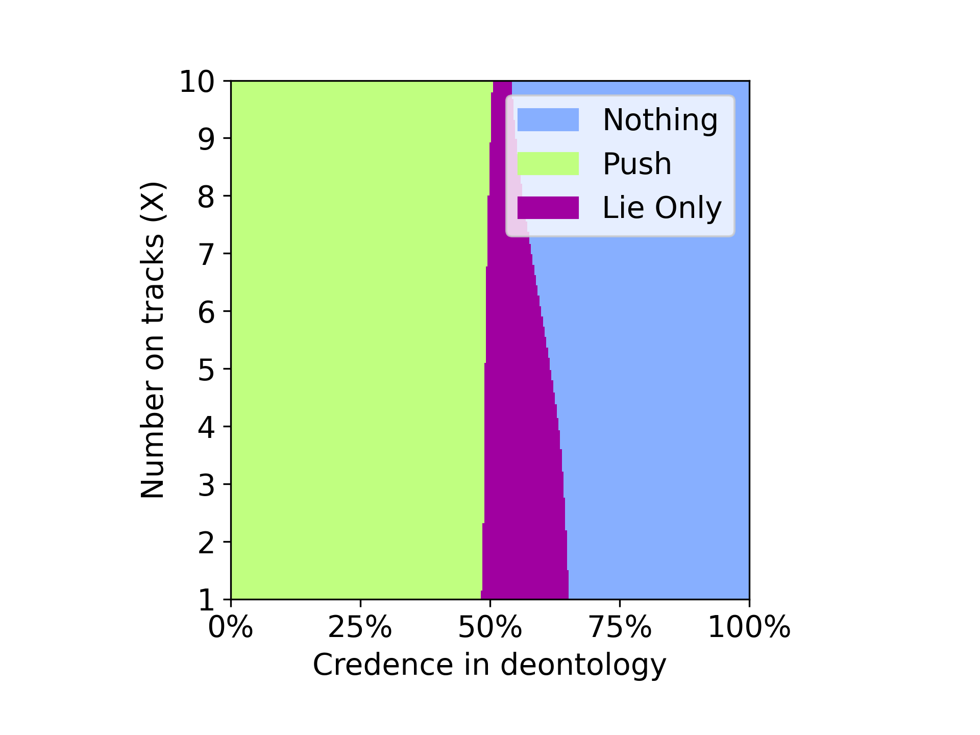

Here we can see that in random credence the agent some times chosen to lie only, making it vulnerable to Illusion of Control problem where the agent thinks that it has the control of the next step where after telling a lie to guard it can push the heavy person on to the track. We can see that the use of Dempster credence made the agent completely immune to the Illusion of Control problem.

We can infer that use of Dempster crendence enhanced the performance of the agent when compared with the random credence.

Guard



Nothing: Will let the trolley hit the X no of people on track

Push: Will push the heavy person on the track to stop the trolley by lie

Lie only: Will lie to the guard but not push the person

**Variance Voting**

Dempster Credence Random Credence

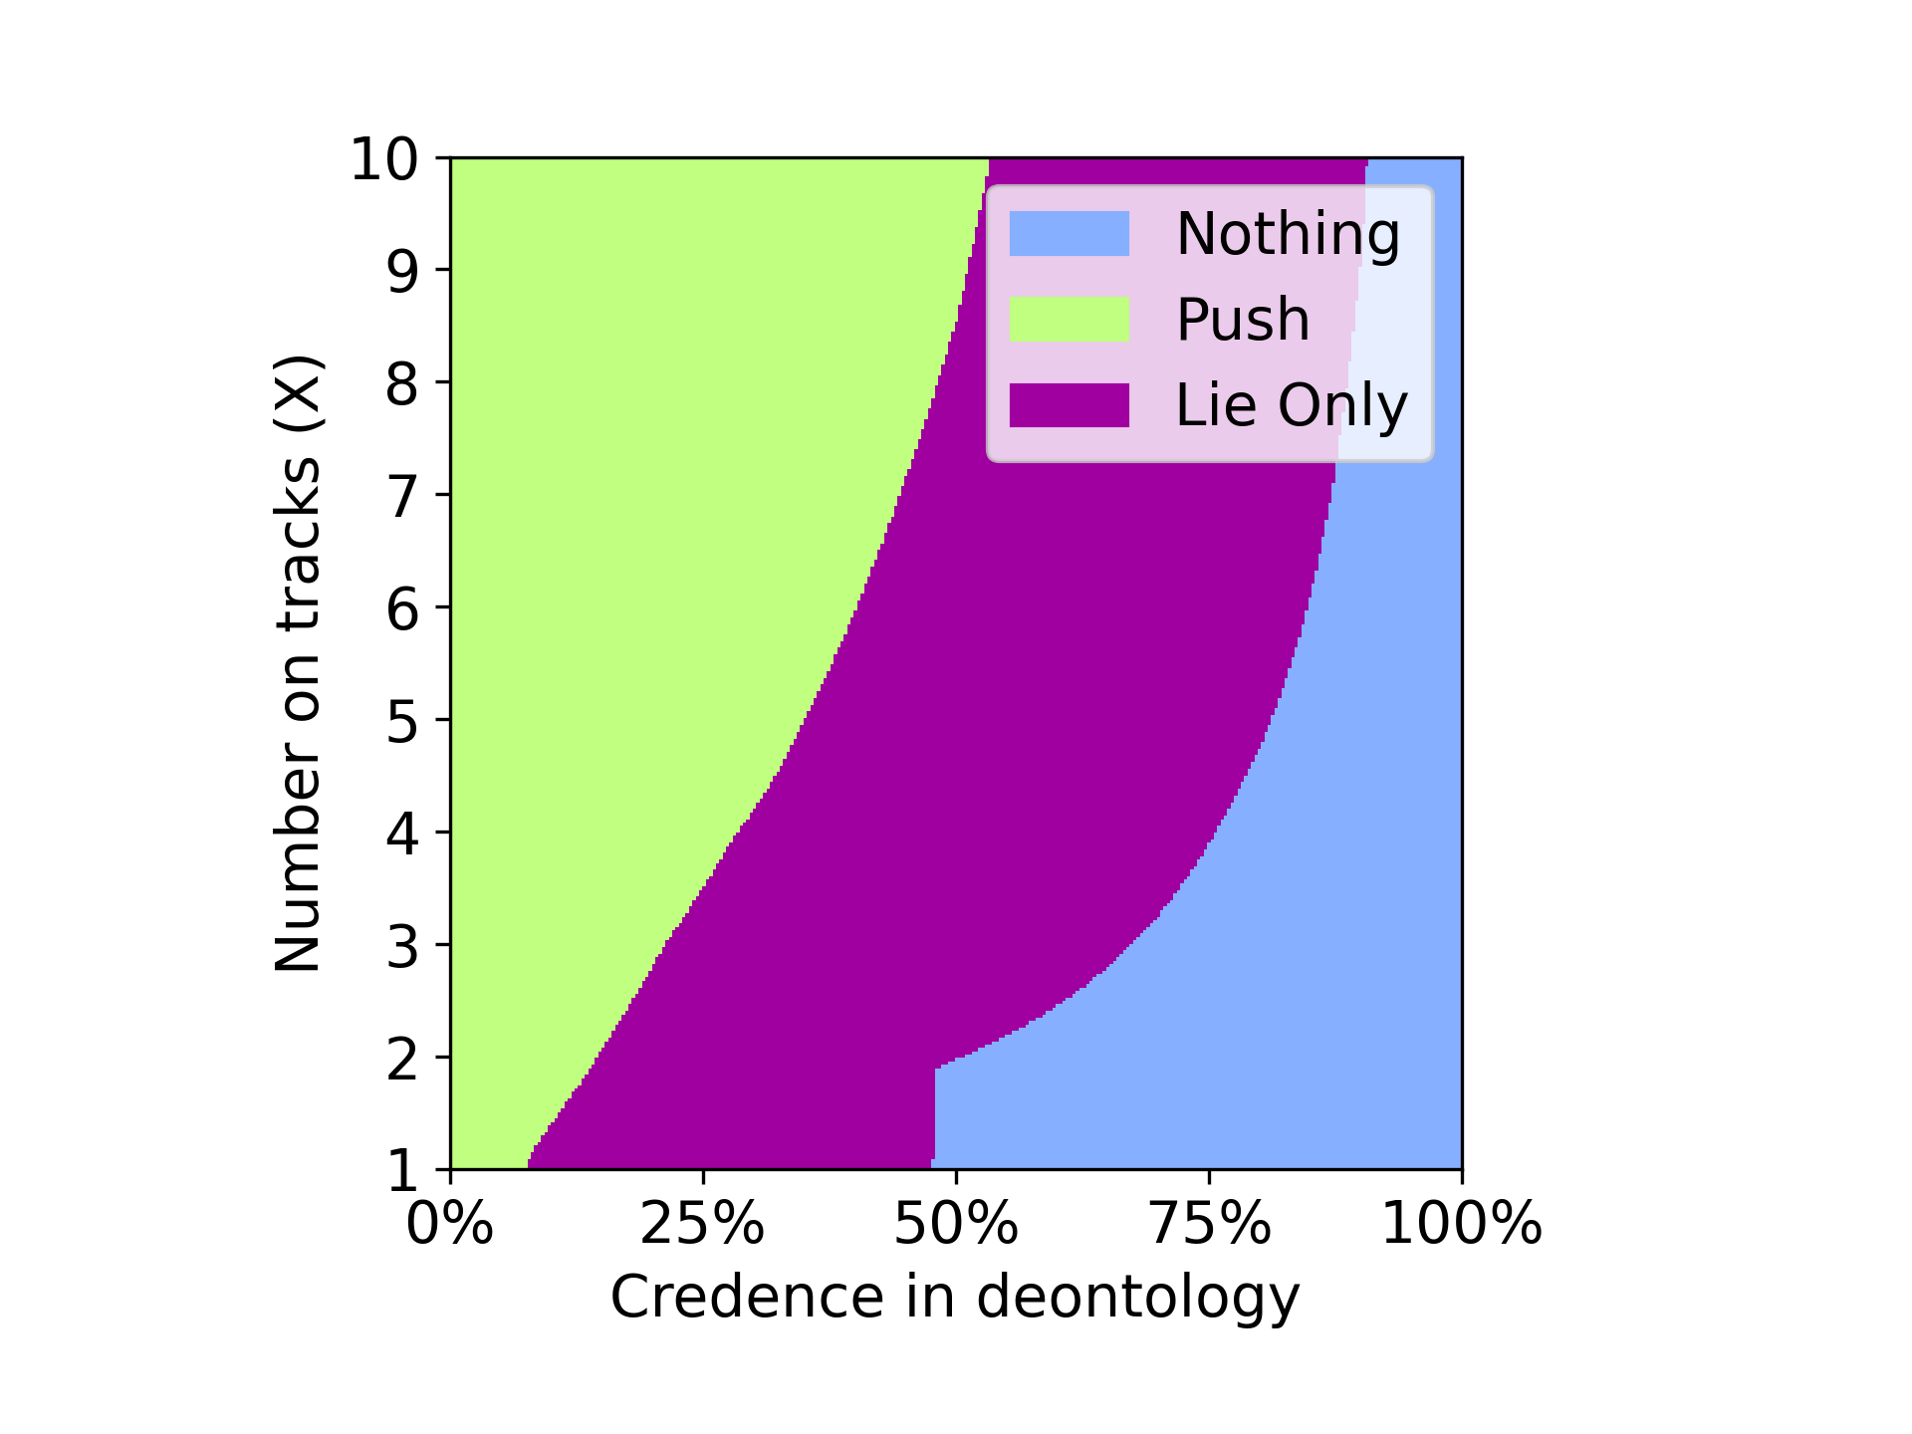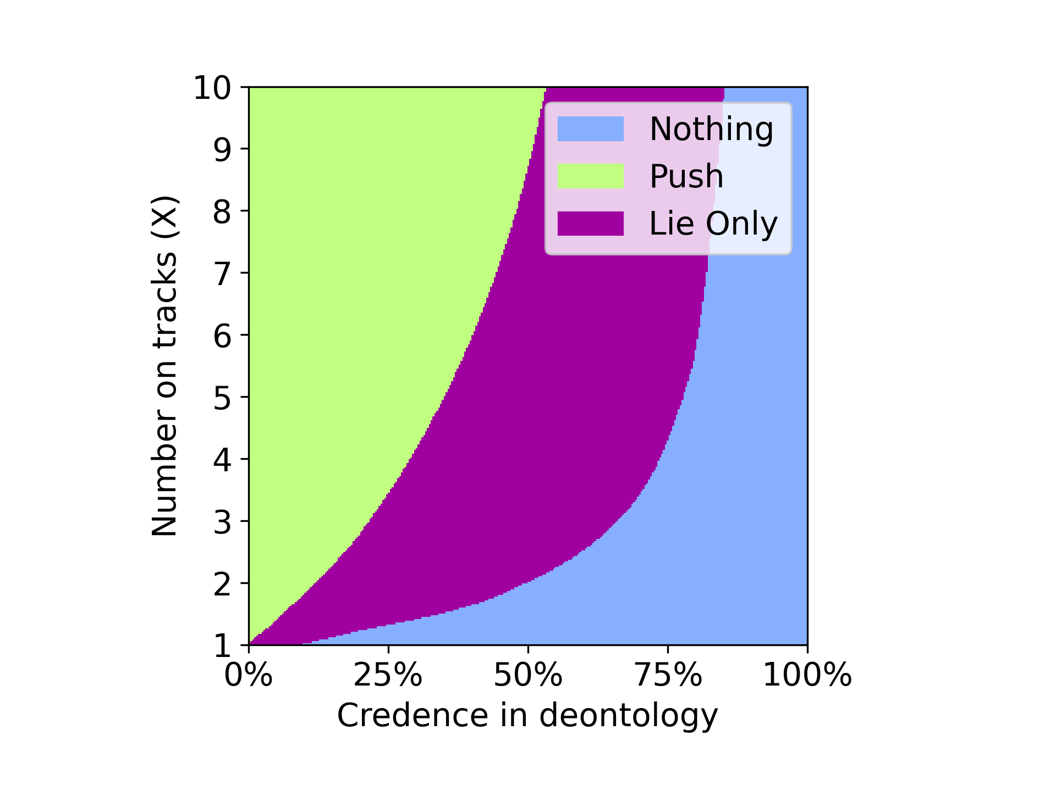

The above plots describe the behavior of the agent with variance voting with Dempster credence and random credence. We can see that in the case of Dempster credence the agent opt to push till 10% of the time when the no of people on the track is 1 and choose to push until 50% of the time when the no of the people on the track is 10. In the random credence case the agent chooses to lie only from the start of the simulation and follow the same till 90% of the time. Here even though the agents are effected with Illusion of Control, agent with the Dempster credence performed better by choosing to push instead of lie only more no of times than the agent with random credence.

Doomsday

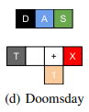

Nothing: Will let the trolley hit the X no of people on track

Switch: will change the direction of the trolley towards the 1 person on side track

**Nash Voting**

Dempster Credence Random Credence

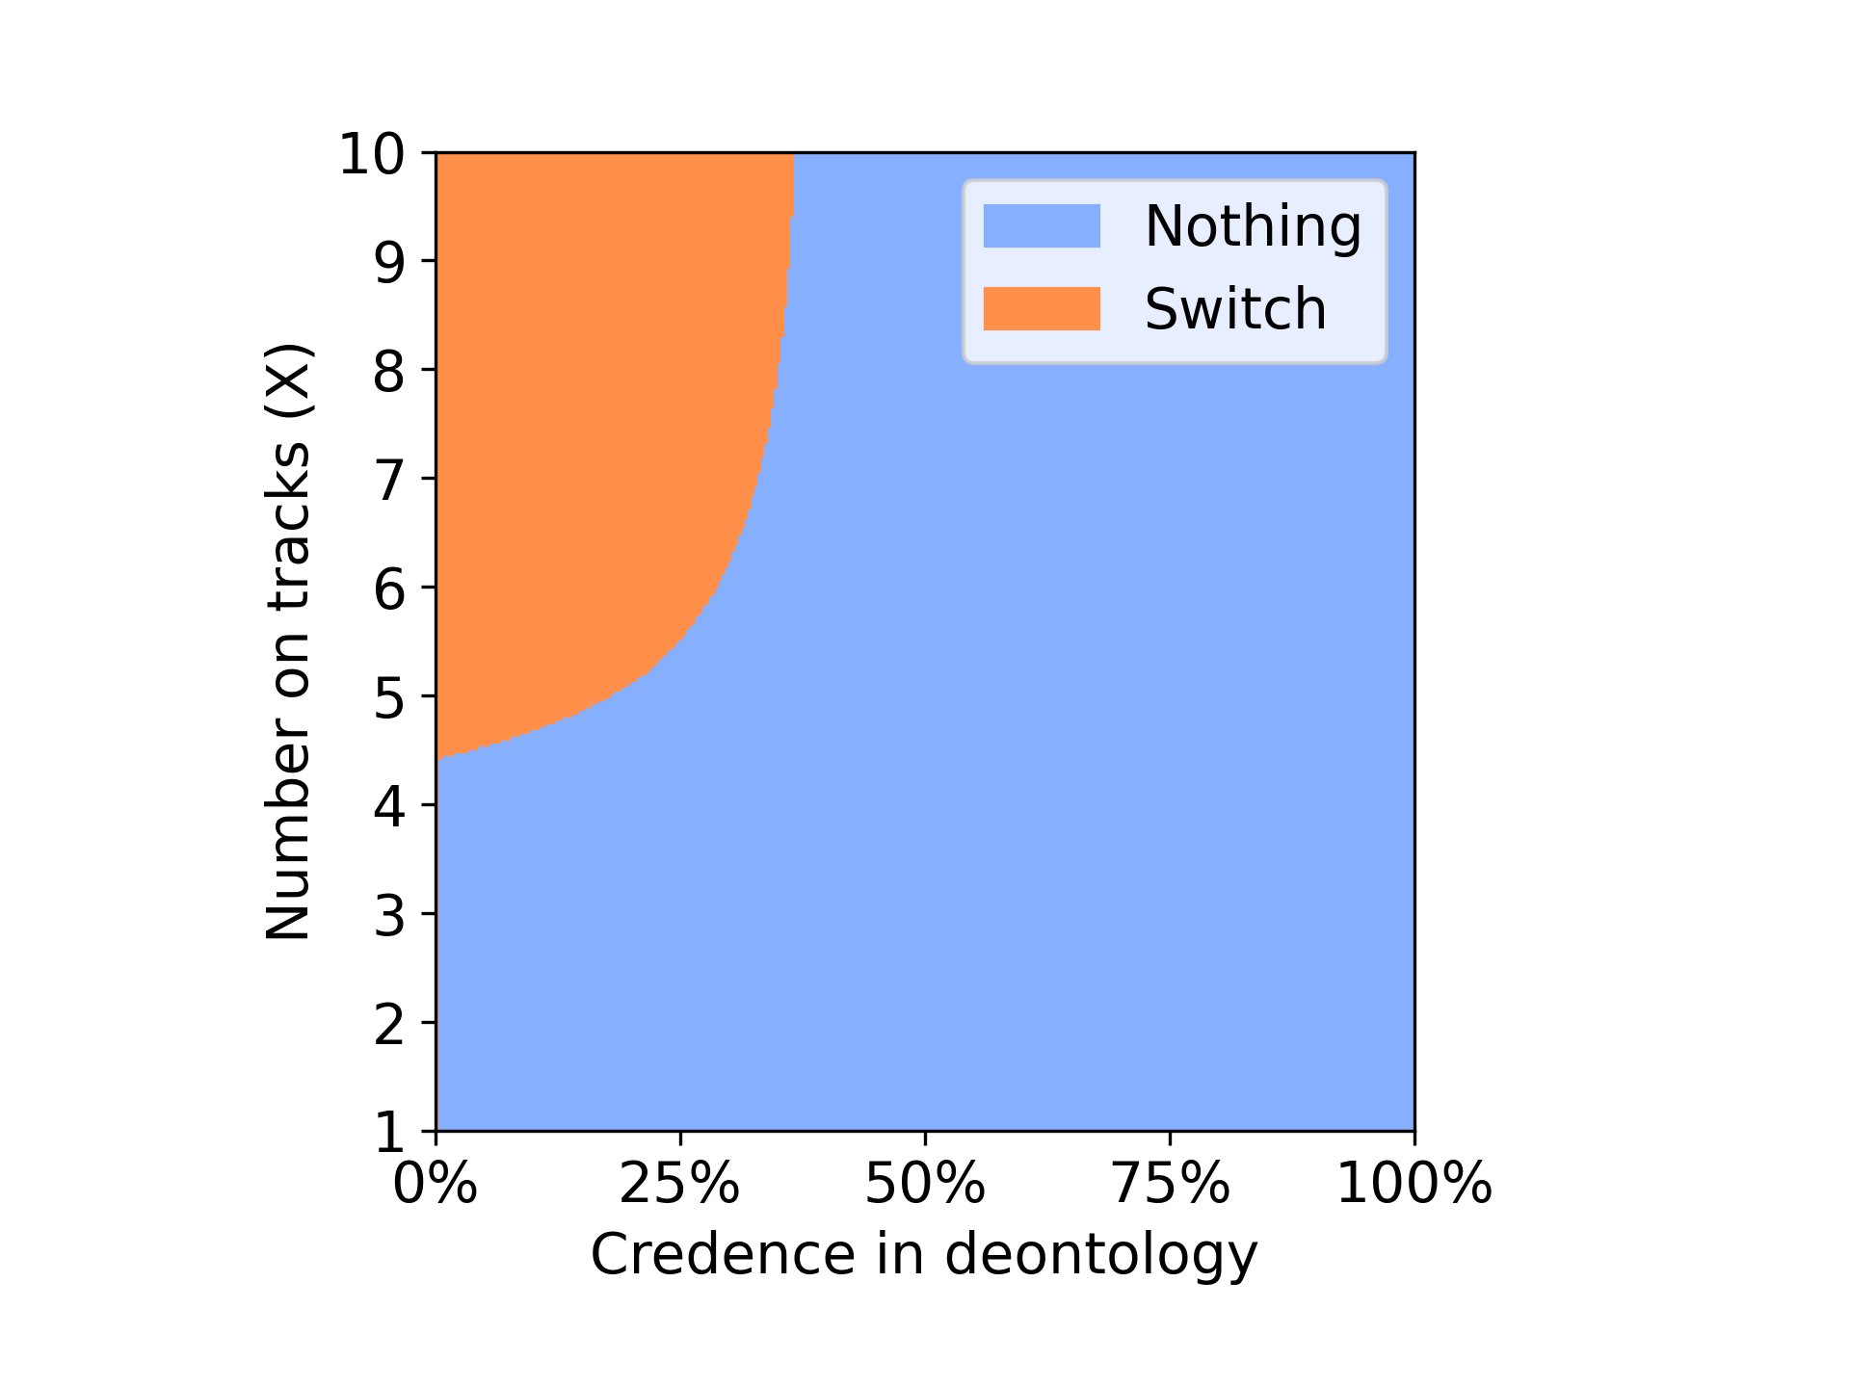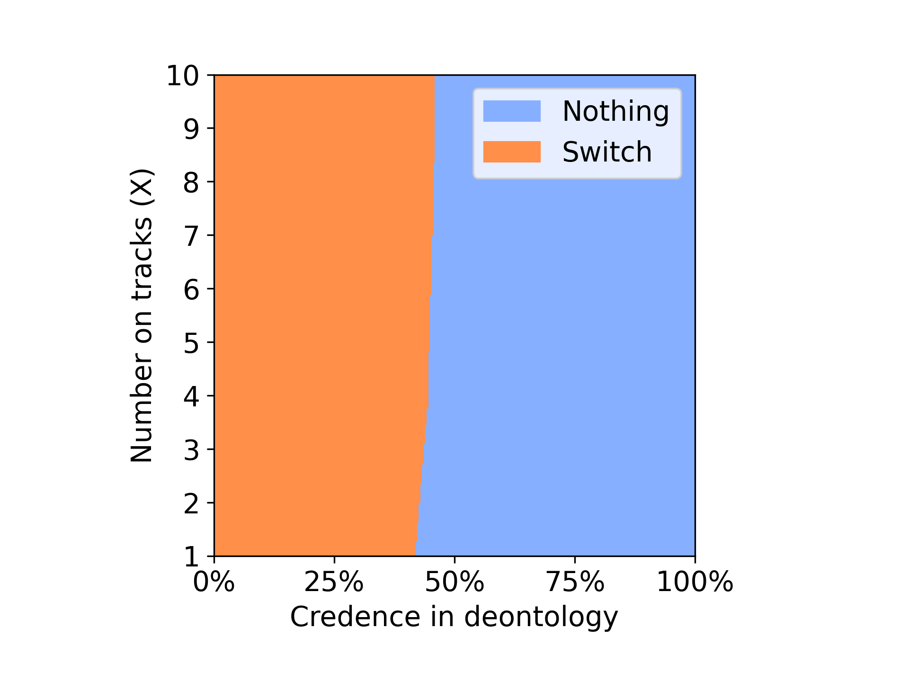

From the above plots we can see that the agent with the Dempster credence only choose to switch when the no of the people is greater than 4 and till 30% of the time. Whereas when the agent used random credence the agent was able to choose switch for around 50 % of the time in a doomsday scenario with nash voting model.

Doomsday



Nothing: Will let the trolley hit the X no of people on track

Switch: will change the direction of the trolley towards the 1 person on side track

**Variance Voting**

Dempster Credence Random Credence

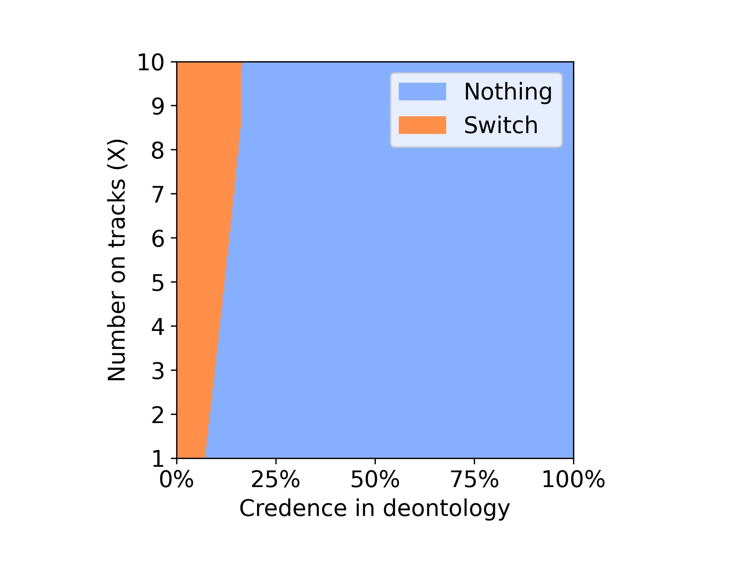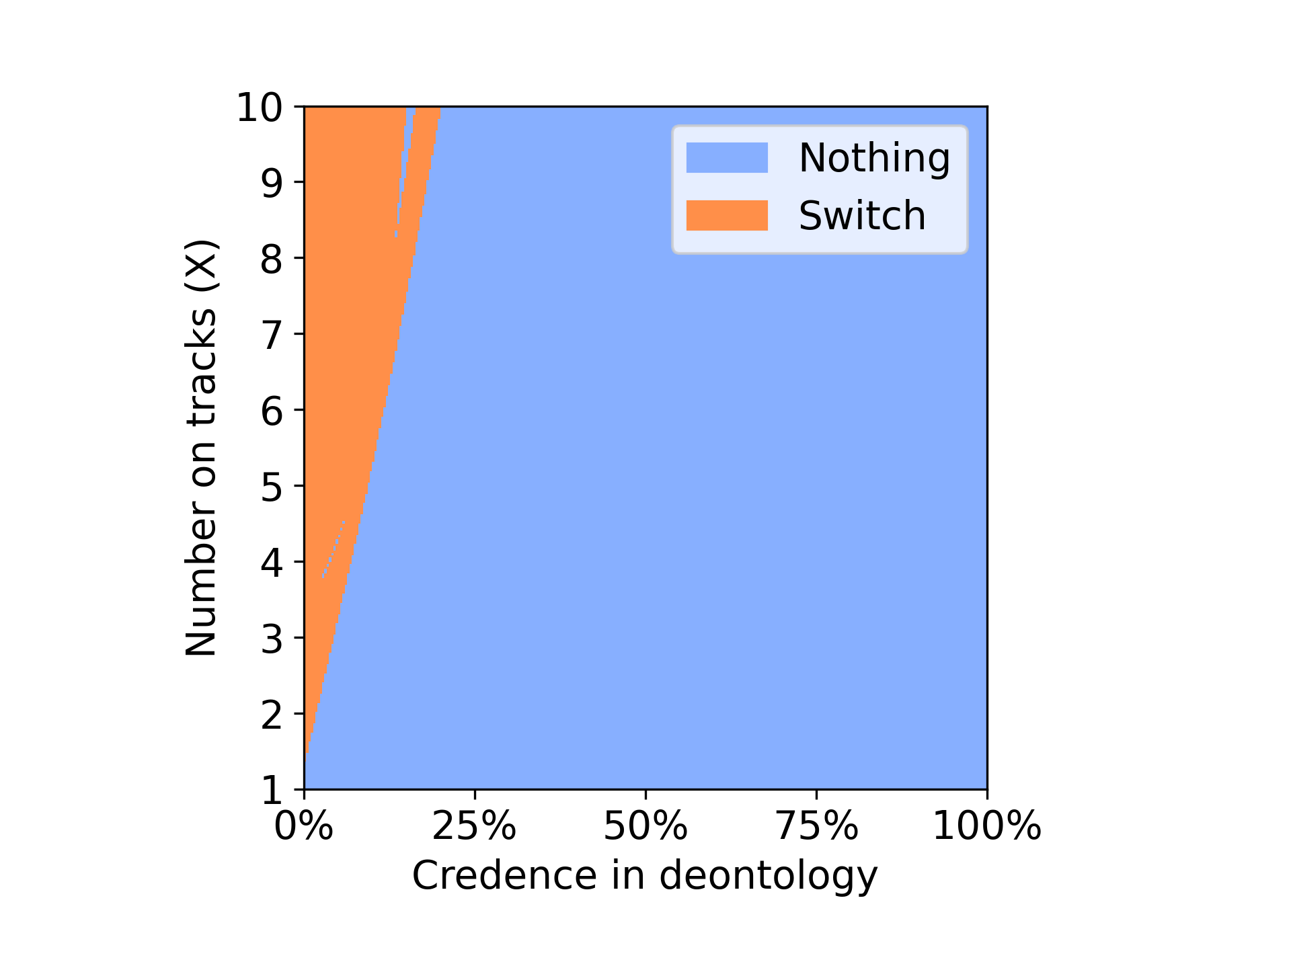

From the plot of Dempster credence using variance voting model in doomsday scenario we can observe that the agent was able to choose the option to switch right from the beginning will 20 % of the time, where as in the case with random credence the agent was unable to choose the option to switch for as many times as the agent with Dempster credence. We can infer from the plots that the agent with Dempster credence is performing better than the random credence by saving the more no of people.

New Classic Environment: 10000 iterations



Nothing: Will let the trolley hit the X no of people on track

Safe turn: will change the direction of the trolley towards the side track where there are no people

**Nash Voting**

Dempster Credence Random Credence

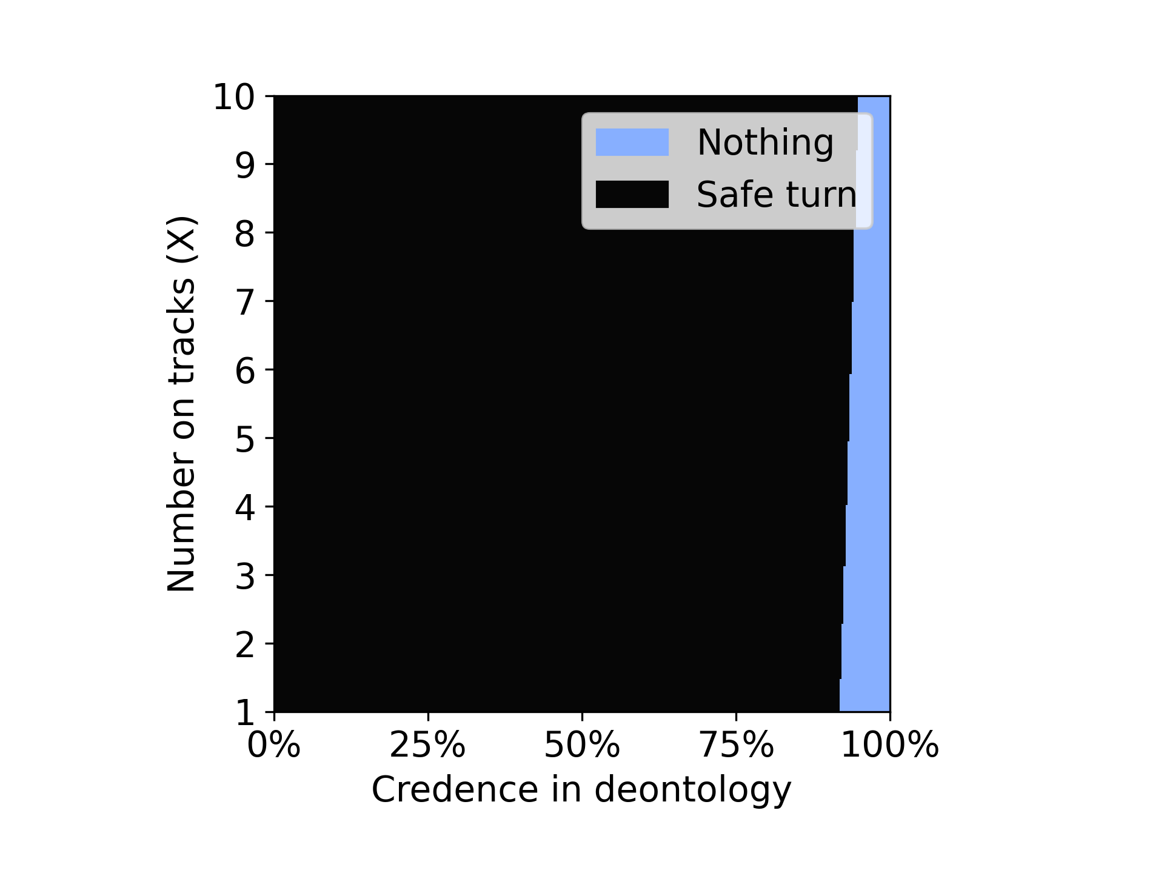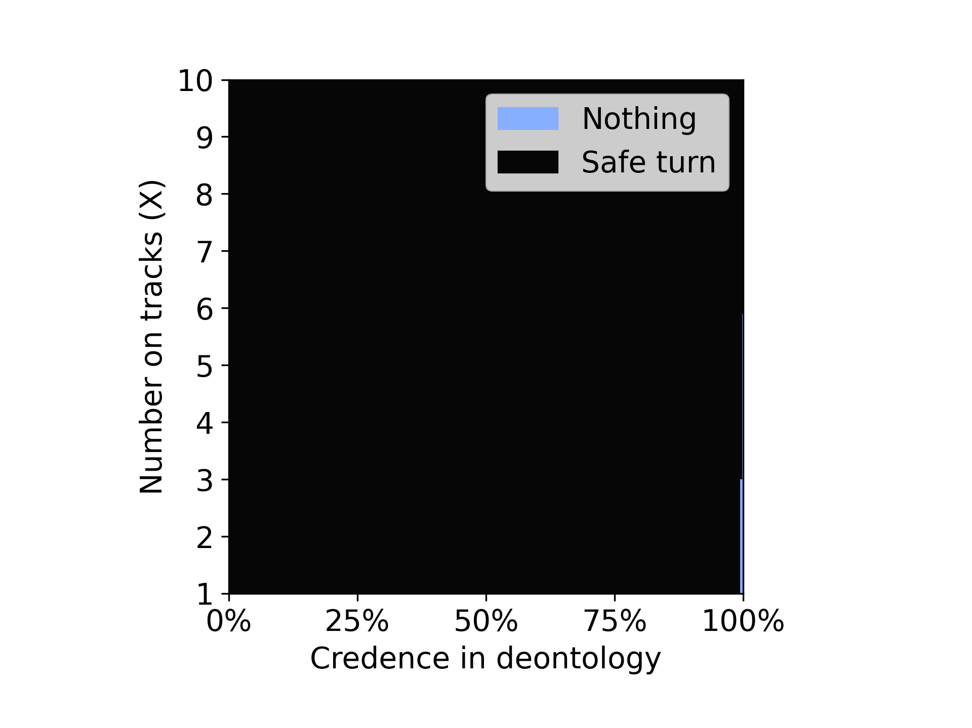

Here we have created a new environment where there will be no people on the side tracks. This makes the choice a safe turn with out having any collateral damage. Choosing the safe turn is the best choice in the both theories as it will not cause any harm even when chosen and will yield high reward for utilitarian.

From the above plots we can see that in both the cases the agent choosed the safe turn option most of the times but it was high in the random credence case.

New Classic Environment:10000 iterations



Nothing: Will let the trolley hit the X no of people on track

Safe turn: will change the direction of the trolley towards the side track where there are no people

**Variance Voting**

Dempster Credence Random Credence

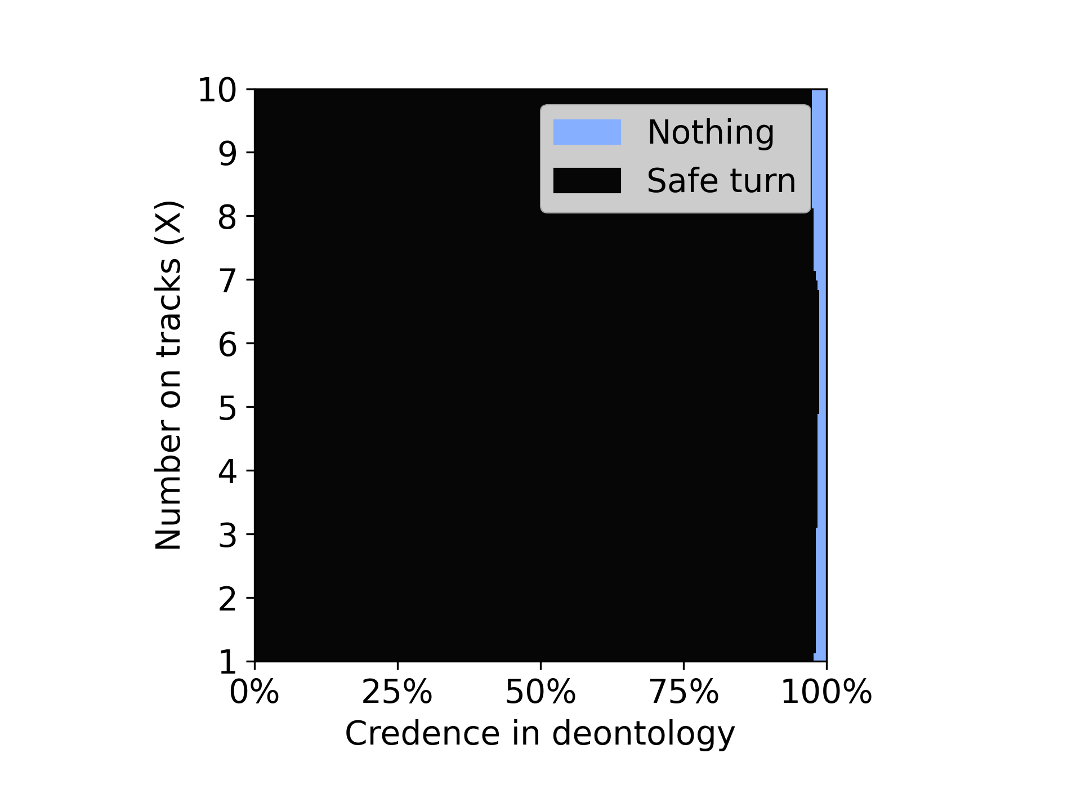 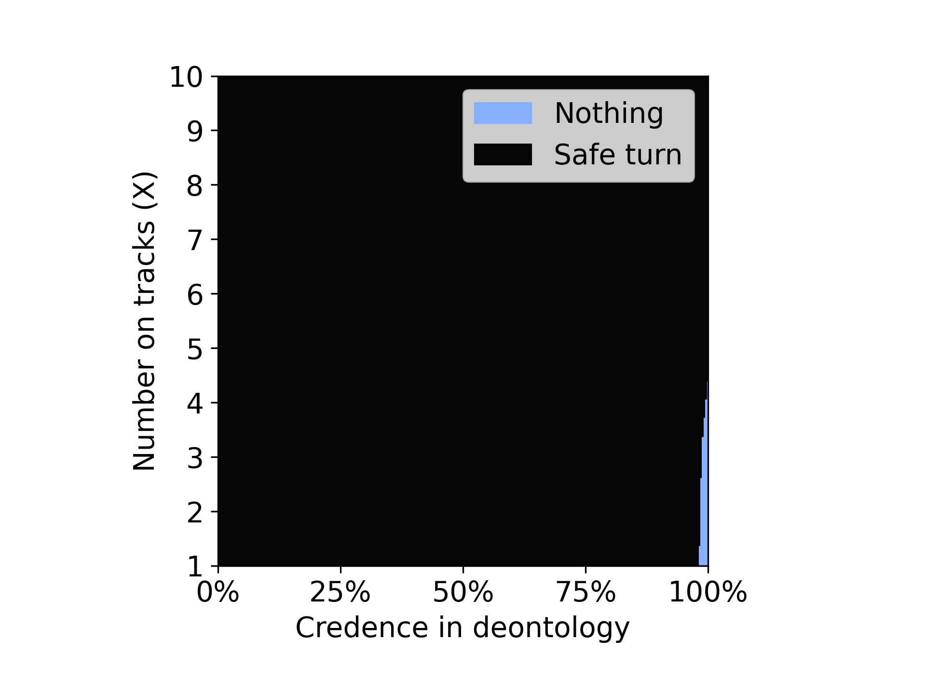

From the above plots its clear that the agent with Dempster credence was able to choose nothing option even though choosing nothing is not any theory’s preference. Where as in the random credence case we can see that the agent has chosen safe turn the most of the times.